# ***Name – Avinash Kumar Pandey***

# ***University Roll number – 2204921540037***

# ***Mini Project Code – BCCS351***

# HTML AND CSS CODE FOR CONTACT PAGE:

<!DOCTYPE html>

<html lang="en">

<head>

<meta charset="UTF-8">

<meta http-equiv="X-UA-Compatible" content="IE=edge">

<meta name="viewport" content="width=device-width, initial-scale=1.0">

<title>Website With Login & Registration | Codehal</title>

<link rel="stylesheet" href="../Css/Contact.css">

</head>

<body>

<header>

<!-- <img class="fit-picture"src="Logo.jpg"alt="logo"srcset="Logo.jpg 8x"> -->

<h2 class="logo">SINGH SAAB</h2>

<nav class="navigation">

<a class="nav" href="../index.html">Home</a>

<a class="nav" href="./Snacks.html">Snacks</a>

<a class="nav" href="./MainCourse.html">Main Course</a>

<a class="nav" href="./Contact.html">Contact</a>

<button class="btnLogin-popup">Login</button>

</nav>

</header>

<div class="wrapper">

<span class="icon-close"><ion-icon name="close"></ion-icon></span>

<div class="form-box login">

<h2>Login</h2>

<form action="#">

<div class="input-box">

<span class="icon"><ion-icon name="mail"></ion-icon></span>

<input type="email" required>

<label>Email</label>

</div>

<div class="input-box">

<span class="icon"><ion-icon name="lock-closed"></ion-icon></span>

<input type="password" required>

<label>Password</label>

</div>

<div class="remember-forgot">

<label><input type="checkbox">Remember me</label>

<a href="#">Forgot Password?</a>

</div>

<button type="submit" class="btn">Login</button>

<div class="login-register">

<p>Don't have an account ?<a href="#" class="register-link">Register</a></p>

</div>

</form>

</div>

<div class="form-box register">

<h2>Registration</h2>

<form action="#">

<div class="input-box">

<span class="icon"><ion-icon name="person"></ion-icon></span>

<input type="text" required>

<label>Username</label>

</div>

<div class="input-box">

<span class="icon"><ion-icon name="mail"></ion-icon></span>

<input type="email" required>

<label>Email</label>

</div>

<div class="input-box">

<span class="icon"><ion-icon name="lock-closed"></ion-icon></span>

<input type="password" required>

<label>Password</label>

</div>

<div class="remember-forgot">

<label><input type="checkbox">I agree to the terms & conditions</label>

</div>

<button type="submit" class="btn">Sign Up</button>

<div class="login-register">

<p>Already have an account ?<a href="#" class="login-link">Login</a></p>

</div>

</form>

</div>

</div>

<script src="../Js/script.js"></script>

<script type="module" src="https://unpkg.com/ionicons@5.5.2/dist/ionicons/ionicons.esm.js"></script>

<script nomodule src="https://unpkg.com/ionicons@5.5.2/dist/ionicons/ionicons.js"></script>

<footer>

Made with &hearts; by Aditya Raj<br />

</footer>

</body>

</html>

# CSS PART:

@import url('https://fonts.googleapis.com/css2?family=Poppins:wght@300;400;500;600;700;800;900&display=swap');

* {

margin: 0;

padding: 0;

box-sizing: border-box;

font-family: 'Poppins', sans-serif;

}

body {

display: flex;

justify-content: center;

align-items: center;

min-height: 100vh;

background: url('../Image/Contact.jpg')no-repeat;

background-size:cover;

background-position: center;

}

header {

position: fixed;

top: 0;

left: 0;

width: 100%;

padding: 20px 100px;

/* background-color: #507DBC; */

display: flex;

justify-content: space-between;

align-items: center;

z-index: 99;

}

.logo {

font-size: 2em;

color: #DAE3E5;

user-select: none;

}

.navigation a {

position: relative;

font-size: 1.1em;

color: #DAE3E5;

text-decoration: none;

font-weight: 500;

}

.navigation a::after {

content: '';

position: absolute;

left: 0;

bottom: -6px;

width: 100%;

height: 3px;

background: #DAE3E5;

border-radius: 5px;

transform-origin: right;

transform: scaleX(0);

transition: transform .5s;

}

.navigation a:hover::after {

transform-origin: left;

transform: scaleX(1);

}

.navigation .btnLogin-popup {

width: 130px;

height: 50px;

background: transparent;

border: 2px solid #DAE3E5;

outline: none;

border-radius: 6px;

cursor: pointer;

font-size: 1.1em;

color: #DAE3E5;

font-weight: 500;

margin-left: 40px;

transition: .5s;

}

.navigation .btnLogin-popup:hover {

background: #DAE3E5;

color: #507DBC;

}

.wrapper {

position: relative;

width: 400px;

height: 440px;

background: transparent;

border: 2px solid rgba(0, 0, 0, .5);

border-radius: 20px;

backdrop-filter: blur(20px);

box-shadow: 0 0 30px rgba(0, 0, 0, .5);

display: flex;

justify-content: center;

align-items: center;

overflow: hidden;

transform: scale(0);

transition: transform .5s ease, height .2s ease;

}

.wrapper.active-popup{

transform: scale(1);

}

.wrapper.active{

height:520px;

}

.wrapper .form-boxs {

width: 100%;

padding: 40px;

}

.wrapper .form-box.login{

transition:transform .18s ease;

transform: translateX(0);

}

.wrapper.active .form-box.login{

transition: none;

transform: translateX(-400px);

}

.wrapper .form-box.register{

position: absolute;

transition: none;

transform: translateX(400px);

}

.wrapper.active .form-box.register{

transition:transform .18s ease;

transform: translateX(0);

}

.wrapper .icon-close{

position: absolute;

top: 0;

right: 0;

width: 45px;

height:45px;

background:#04080F;

font-size: 2em;

color: #DAE3E5;

display: flex;

justify-content: center;

align-items: center;

border-bottom-left-radius: 20px;

z-index: 1;

}

.form-box h2 {

font-size: 2em;

color: #04080F;

text-align: center;

}

.input-box {

position: relative;

width: 100%;

height: 50px;

border-bottom: 2px solid #04080F;

margin: 30px 0;

}

.input-box label {

position: absolute;

top: 50%;

left: 5px;

transform: translateY(-50%);

font-size: 1em;

color: #04080F;

font-weight: 500;

pointer-events: nones;

transition: .5s;

}

.input-box input:focus~label,

.input-box input:valid~label {

top: -5px;

}

.input-box input {

width: 100%;

height: 100%;

background: transparent;

border: none;

outline: none;

font-size: 1em;

color: #04080F;

font-weight: 600;

padding: 0 35px 0 5px;

}

.input-box .icon {

position: absolute;

right: 8px;

font-size: 1.2em;

color: #04080F;

line-height: 57px;

}

.remember-forgot {

font-size: .9em;

color: #04080F;

font-weight: 500;

margin: -15px 0 15px;

display:flex;

flex-direction: column;

justify-content: space-between;

}

.remember-forgot label input {

accent-color: #04080F;

margin-right: 3px;

}

.remember-forgot a {

color: #04080F;

text-decoration: none;

}

.remember-forgot a:hover {

text-decoration: underline;

}

.btn {

width: 100%;

height: 45px;

background: #04080F;

border: none;

outline: none;

border-radius: 6px;

cursor: pointer;

font-size: 1em;

color: #DAE3E5;

font-weight: 500;

}

.login-register {

font-size: .9em;

color: #04080F;

text-align: center;

font-weight: 500;

margin: 25px 0 10px;

}

.login-register p a {

color: #04080F;

text-decoration: none;

font-weight: 600;

}

.login-register p a:hover {

text-decoration: underline;

}

.nav{

margin-right: 50px;

}

footer{

position: fixed;

bottom: 0;

left: 35%;

width: 100%;

padding: 20px 100px;

/* background-color: #507DBC; */

display: flex;

justify-content: space-between;

align-items: center;

z-index: 99;

color:#DAE3E5;

font-family: 'Times New Roman', Times, serif;

font-weight: bold;

}

# OUTPUT:

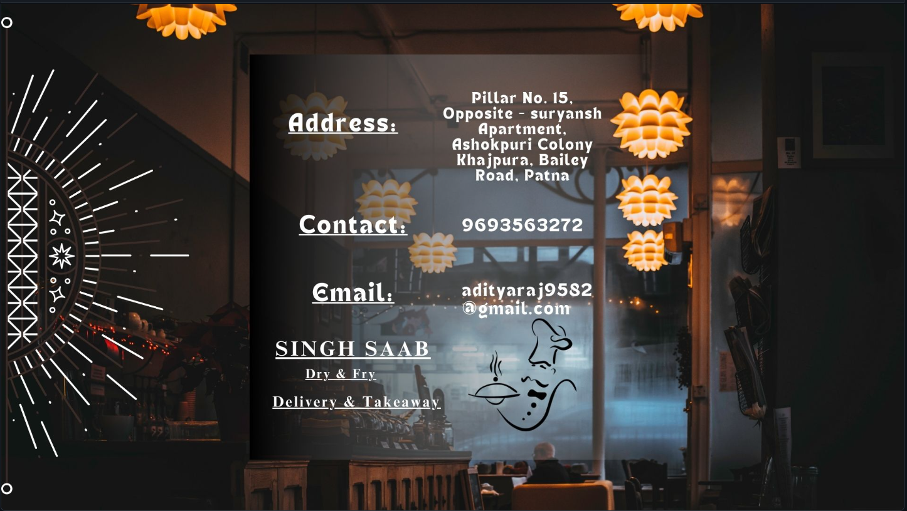

# HTML FOR MAIN COURSE:

<!DOCTYPE html>

<html lang="en">

<head>

<meta charset="UTF-8">

<meta http-equiv="X-UA-Compatible" content="IE=edge">

<meta name="viewport" content="width=device-width, initial-scale=1.0">

<title>Website With Login & Registration | Codehal</title>

<link rel="stylesheet" href="../Css/MainCourse.css">

</head>

<body>

<header>

<!-- <img class="fit-picture"src="Logo.jpg"alt="logo"srcset="Logo.jpg 8x"> -->

<h2 class="logo">SINGH SAAB</h2>

<nav class="navigation">

<a class="nav" href="../index.html">Home</a>

<a class="nav" href="./Snacks.html">Snacks</a>

<a class="nav" href="./MainCourse.html">Main Course</a>

<a class="nav" href="./Contact.html">Contact</a>

<button class="btnLogin-popup">Login</button>

</nav>

</header>

<div class="wrapper">

<span class="icon-close"><ion-icon name="close"></ion-icon></span>

<div class="form-box login">

<h2>Login</h2>

<form action="#">

<div class="input-box">

<span class="icon"><ion-icon name="mail"></ion-icon></span>

<input type="email" required>

<label>Email</label>

</div>

<div class="input-box">

<span class="icon"><ion-icon name="lock-closed"></ion-icon></span>

<input type="password" required>

<label>Password</label>

</div>

<div class="remember-forgot">

<label><input type="checkbox">Remember me</label>

<a href="#">Forgot Password?</a>

</div>

<button type="submit" class="btn">Login</button>

<div class="login-register">

<p>Don't have an account ?<a href="#" class="register-link">Register</a></p>

</div>

</form>

</div>

<div class="form-box register">

<h2>Registration</h2>

<form action="#">

<div class="input-box">

<span class="icon"><ion-icon name="person"></ion-icon></span>

<input type="text" required>

<label>Username</label>

</div>

<div class="input-box">

<span class="icon"><ion-icon name="mail"></ion-icon></span>

<input type="email" required>

<label>Email</label>

</div>

<div class="input-box">

<span class="icon"><ion-icon name="lock-closed"></ion-icon></span>

<input type="password" required>

<label>Password</label>

</div>

<div class="remember-forgot">

<label><input type="checkbox">I agree to the terms & conditions</label>

</div>

<button type="submit" class="btn">Sign Up</button>

<div class="login-register">

<p>Already have an account ?<a href="#" class="login-link">Login</a></p>

</div>

</form>

</div>

</div>

<script src="../Js/script.js"></script>

<script type="module" src="https://unpkg.com/ionicons@5.5.2/dist/ionicons/ionicons.esm.js"></script>

<script nomodule src="https://unpkg.com/ionicons@5.5.2/dist/ionicons/ionicons.js"></script>

<footer>

Made with &hearts; by Aditya Raj<br />

</footer>

</body>

</html>

# CSS FOR MAIN COURSE:

@import url('https://fonts.googleapis.com/css2?family=Poppins:wght@300;400;500;600;700;800;900&display=swap');

* {

margin: 0;

padding: 0;

box-sizing: border-box;

font-family: 'Poppins', sans-serif;

}

body {

display: flex;

justify-content: center;

align-items: center;

min-height: 100vh;

background: url('../Image/MainCourse.jpg')no-repeat;

background-size:cover;

background-position: center;

}

header {

position: fixed;

top: 0;

left: 0;

width: 100%;

padding: 20px 100px;

/* background-color: #507DBC; */

display: flex;

justify-content: space-between;

align-items: center;

z-index: 99;

}

.logo {

font-size: 2em;

color: #DAE3E5;

user-select: none;

}

.navigation a {

position: relative;

font-size: 1.1em;

color: #DAE3E5;

text-decoration: none;

font-weight: 500;

}

.navigation a::after {

content: '';

position: absolute;

left: 0;

bottom: -6px;

width: 100%;

height: 3px;

background: #DAE3E5;

border-radius: 5px;

transform-origin: right;

transform: scaleX(0);

transition: transform .5s;

}

.navigation a:hover::after {

transform-origin: left;

transform: scaleX(1);

}

.navigation .btnLogin-popup {

width: 130px;

height: 50px;

background: transparent;

border: 2px solid #DAE3E5;

outline: none;

border-radius: 6px;

cursor: pointer;

font-size: 1.1em;

color: #DAE3E5;

font-weight: 500;

margin-left: 40px;

transition: .5s;

}

.navigation .btnLogin-popup:hover {

background: #DAE3E5;

color: #507DBC;

}

.wrapper {

position: relative;

width: 400px;

height: 440px;

background: transparent;

border: 2px solid rgba(0, 0, 0, .5);

border-radius: 20px;

backdrop-filter: blur(20px);

box-shadow: 0 0 30px rgba(0, 0, 0, .5);

display: flex;

justify-content: center;

align-items: center;

overflow: hidden;

transform: scale(0);

transition: transform .5s ease, height .2s ease;

}

.wrapper.active-popup{

transform: scale(1);

}

.wrapper.active{

height:520px;

}

.wrapper .form-boxs {

width: 100%;

padding: 40px;

}

.wrapper .form-box.login{

transition:transform .18s ease;

transform: translateX(0);

}

.wrapper.active .form-box.login{

transition: none;

transform: translateX(-400px);

}

.wrapper .form-box.register{

position: absolute;

transition: none;

transform: translateX(400px);

}

.wrapper.active .form-box.register{

transition:transform .18s ease;

transform: translateX(0);

}

.wrapper .icon-close{

position: absolute;

top: 0;

right: 0;

width: 45px;

height:45px;

background:#04080F;

font-size: 2em;

color: #DAE3E5;

display: flex;

justify-content: center;

align-items: center;

border-bottom-left-radius: 20px;

z-index: 1;

}

.form-box h2 {

font-size: 2em;

color: #04080F;

text-align: center;

}

.input-box {

position: relative;

width: 100%;

height: 50px;

border-bottom: 2px solid #04080F;

margin: 30px 0;

}

.input-box label {

position: absolute;

top: 50%;

left: 5px;

transform: translateY(-50%);

font-size: 1em;

color: #04080F;

font-weight: 500;

pointer-events: nones;

transition: .5s;

}

.input-box input:focus~label,

.input-box input:valid~label {

top: -5px;

}

.input-box input {

width: 100%;

height: 100%;

background: transparent;

border: none;

outline: none;

font-size: 1em;

color: #04080F;

font-weight: 600;

padding: 0 35px 0 5px;

}

.input-box .icon {

position: absolute;

right: 8px;

font-size: 1.2em;

color: #04080F;

line-height: 57px;

}

.remember-forgot {

font-size: .9em;

color: #04080F;

font-weight: 500;

margin: -15px 0 15px;

display:flex;

flex-direction: column;

justify-content: space-between;

}

.remember-forgot label input {

accent-color: #04080F;

margin-right: 3px;

}

.remember-forgot a {

color: #04080F;

text-decoration: none;

}

.remember-forgot a:hover {

text-decoration: underline;

}

.btn {

width: 100%;

height: 45px;

background: #04080F;

border: none;

outline: none;

border-radius: 6px;

cursor: pointer;

font-size: 1em;

color: #DAE3E5;

font-weight: 500;

}

.login-register {

font-size: .9em;

color: #04080F;

text-align: center;

font-weight: 500;

margin: 25px 0 10px;

}

.login-register p a {

color: #04080F;

text-decoration: none;

font-weight: 600;

}

.login-register p a:hover {

text-decoration: underline;

}

.nav{

margin-right: 50px;

}

footer{

position: fixed;

bottom: 0;

left: 35%;

width: 100%;

padding: 20px 100px;

/* background-color: #507DBC; */

display: flex;

justify-content: space-between;

align-items: center;

z-index: 99;

color:#DAE3E5;

font-family: 'Times New Roman', Times, serif;

font-weight: bold;

}

# OUTPUT:

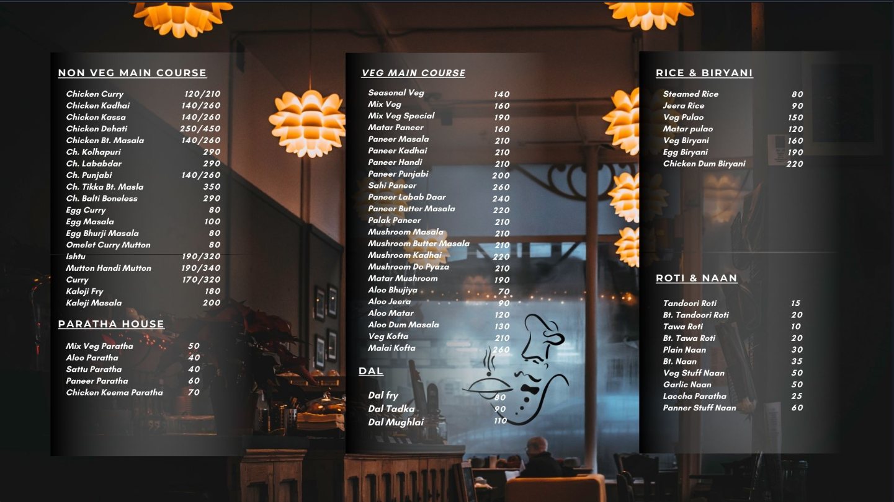

# HTML & JS FOR SNACKS:

<!DOCTYPE html>

<html lang="en">

<head>

<meta charset="UTF-8">

<meta http-equiv="X-UA-Compatible" content="IE=edge">

<meta name="viewport" content="width=device-width, initial-scale=1.0">

<title>Website With Login & Registration | Codehal</title>

<link rel="stylesheet" href="../Css/Snacks.css">

</head>

<body>

<header>

<!-- <img class="fit-picture"src="Logo.jpg"alt="logo"srcset="Logo.jpg 8x"> -->

<h2 class="logo">SINGH SAAB</h2>

<nav class="navigation">

<a class="nav" href="../index.html">Home</a>

<a class="nav" href="./Snacks.html">Snacks</a>

<a class="nav" href="./MainCourse.html">Main Course</a>

<a class="nav" href="./Contact.html">Contact</a>

<button class="btnLogin-popup">Login</button>

</nav>

</header>

<div class="wrapper">

<span class="icon-close"><ion-icon name="close"></ion-icon></span>

<div class="form-box login">

<h2>Login</h2>

<form action="#">

<div class="input-box">

<span class="icon"><ion-icon name="mail"></ion-icon></span>

<input type="email" required>

<label>Email</label>

</div>

<div class="input-box">

<span class="icon"><ion-icon name="lock-closed"></ion-icon></span>

<input type="password" required>

<label>Password</label>

</div>

<div class="remember-forgot">

<label><input type="checkbox">Remember me</label>

<a href="#">Forgot Password?</a>

</div>

<button type="submit" class="btn">Login</button>

<div class="login-register">

<p>Don't have an account ?<a href="#" class="register-link">Register</a></p>

</div>

</form>

</div>

<div class="form-box register">

<h2>Registration</h2>

<form action="#">

<div class="input-box">

<span class="icon"><ion-icon name="person"></ion-icon></span>

<input type="text" required>

<label>Username</label>

</div>

<div class="input-box">

<span class="icon"><ion-icon name="mail"></ion-icon></span>

<input type="email" required>

<label>Email</label>

</div>

<div class="input-box">

<span class="icon"><ion-icon name="lock-closed"></ion-icon></span>

<input type="password" required>

<label>Password</label>

</div>

<div class="remember-forgot">

<label><input type="checkbox">I agree to the terms & conditions</label>

</div>

<button type="submit" class="btn">Sign Up</button>

<div class="login-register">

<p>Already have an account ?<a href="#" class="login-link">Login</a></p>

</div>

</form>

</div>

</div>

<script src="../Js/script.js"></script>

<script type="module" src="https://unpkg.com/ionicons@5.5.2/dist/ionicons/ionicons.esm.js"></script>

<script nomodule src="https://unpkg.com/ionicons@5.5.2/dist/ionicons/ionicons.js"></script>

<footer>

Made with &hearts; by Aditya Raj<br />

</footer>

</body>

</html>

# CSS FOR SNACKS:

@import url('https://fonts.googleapis.com/css2?family=Poppins:wght@300;400;500;600;700;800;900&display=swap');

* {

margin: 0;

padding: 0;

box-sizing: border-box;

font-family: 'Poppins', sans-serif;

}

body {

display: flex;

justify-content: center;

align-items: center;

min-height: 100vh;

background: url('../Image/Snacks.jpg')no-repeat;

background-size:cover;

background-position: center;

}

header {

position: fixed;

top: 0;

left: 0;

width: 100%;

padding: 20px 100px;

/* background-color: #507DBC; */

display: flex;

justify-content: space-between;

align-items: center;

z-index: 99;

}

.logo {

font-size: 2em;

color: #DAE3E5;

user-select: none;

}

.navigation a {

position: relative;

font-size: 1.1em;

color: #DAE3E5;

text-decoration: none;

font-weight: 500;

}

.navigation a::after {

content: '';

position: absolute;

left: 0;

bottom: -6px;

width: 100%;

height: 3px;

background: #DAE3E5;

border-radius: 5px;

transform-origin: right;

transform: scaleX(0);

transition: transform .5s;

}

.navigation a:hover::after {

transform-origin: left;

transform: scaleX(1);

}

.navigation .btnLogin-popup {

width: 130px;

height: 50px;

background: transparent;

border: 2px solid #DAE3E5;

outline: none;

border-radius: 6px;

cursor: pointer;

font-size: 1.1em;

color: #DAE3E5;

font-weight: 500;

margin-left: 40px;

transition: .5s;

}

.navigation .btnLogin-popup:hover {

background: #DAE3E5;

color: #507DBC;

}

.wrapper {

position: relative;

width: 400px;

height: 440px;

background: transparent;

border: 2px solid rgba(0, 0, 0, .5);

border-radius: 20px;

backdrop-filter: blur(20px);

box-shadow: 0 0 30px rgba(0, 0, 0, .5);

display: flex;

justify-content: center;

align-items: center;

overflow: hidden;

transform: scale(0);

transition: transform .5s ease, height .2s ease;

}

.wrapper.active-popup{

transform: scale(1);

}

.wrapper.active{

height:520px;

}

.wrapper .form-boxs {

width: 100%;

padding: 40px;

}

.wrapper .form-box.login{

transition:transform .18s ease;

transform: translateX(0);

}

.wrapper.active .form-box.login{

transition: none;

transform: translateX(-400px);

}

.wrapper .form-box.register{

position: absolute;

transition: none;

transform: translateX(400px);

}

.wrapper.active .form-box.register{

transition:transform .18s ease;

transform: translateX(0);

}

.wrapper .icon-close{

position: absolute;

top: 0;

right: 0;

width: 45px;

height:45px;

background:#04080F;

font-size: 2em;

color: #DAE3E5;

display: flex;

justify-content: center;

align-items: center;

border-bottom-left-radius: 20px;

z-index: 1;

}

.form-box h2 {

font-size: 2em;

color: #04080F;

text-align: center;

}

.input-box {

position: relative;

width: 100%;

height: 50px;

border-bottom: 2px solid #04080F;

margin: 30px 0;

}

.input-box label {

position: absolute;

top: 50%;

left: 5px;

transform: translateY(-50%);

font-size: 1em;

color: #04080F;

font-weight: 500;

pointer-events: nones;

transition: .5s;

}

.input-box input:focus~label,

.input-box input:valid~label {

top: -5px;

}

.input-box input {

width: 100%;

height: 100%;

background: transparent;

border: none;

outline: none;

font-size: 1em;

color: #04080F;

font-weight: 600;

padding: 0 35px 0 5px;

}

.input-box .icon {

position: absolute;

right: 8px;

font-size: 1.2em;

color: #04080F;

line-height: 57px;

}

.remember-forgot {

font-size: .9em;

color: #04080F;

font-weight: 500;

margin: -15px 0 15px;

display:flex;

flex-direction: column;

justify-content: space-between;

}

.remember-forgot label input {

accent-color: #04080F;

margin-right: 3px;

}

.remember-forgot a {

color: #04080F;

text-decoration: none;

}

.remember-forgot a:hover {

text-decoration: underline;

}

.btn {

width: 100%;

height: 45px;

background: #04080F;

border: none;

outline: none;

border-radius: 6px;

cursor: pointer;

font-size: 1em;

color: #DAE3E5;

font-weight: 500;

}

.login-register {

font-size: .9em;

color: #04080F;

text-align: center;

font-weight: 500;

margin: 25px 0 10px;

}

.login-register p a {

color: #04080F;

text-decoration: none;

font-weight: 600;

}

.login-register p a:hover {

text-decoration: underline;

}

.nav{

margin-right: 50px;

}

footer{

position: fixed;

bottom: 0;

left: 35%;

width: 100%;

padding: 20px 100px;

/* background-color: #507DBC; */

display: flex;

justify-content: space-between;

align-items: center;

z-index: 99;

color:#DAE3E5;

font-family: 'Times New Roman', Times, serif;

font-weight: bold;

}

# OUTPUT:

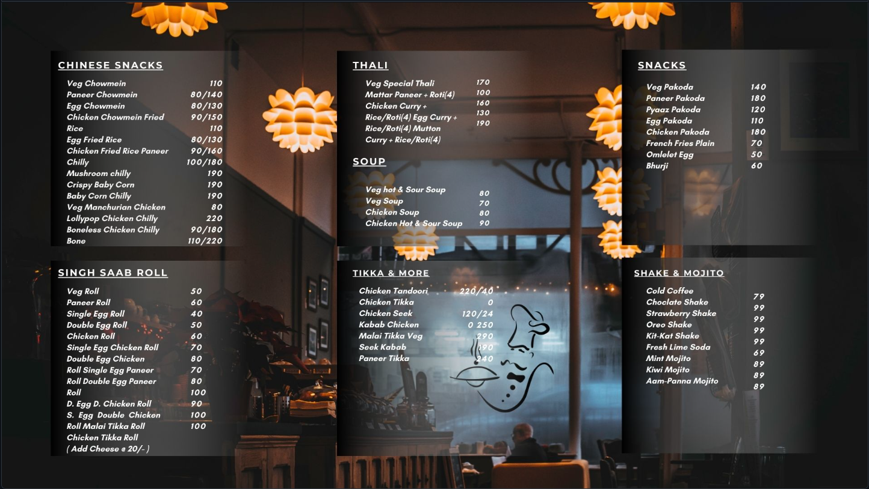

# FOR HOME PAGE:

@import url('https://fonts.googleapis.com/css2?family=Poppins:wght@300;400;500;600;700;800;900&display=swap');

* {

margin: 0;

padding: 0;

box-sizing: border-box;

font-family: 'Poppins', sans-serif;

}

body {

display: flex;

justify-content: center;

align-items: center;

min-height: 100vh;

background: url('../Image/Home.jpg')no-repeat;

background-size:cover;

background-position: center;

}

header {

position: fixed;

top: 0;

left: 0;

width: 100%;

padding: 20px 100px;

/* background-color: #507DBC; */

display: flex;

justify-content: space-between;

align-items: center;

z-index: 99;

}

.logo {

font-size: 2em;

color: #DAE3E5;

user-select: none;

}

.navigation a {

position: relative;

font-size: 1.1em;

color: #DAE3E5;

text-decoration: none;

font-weight: 500;

}

.navigation a::after {

content: '';

position: absolute;

left: 0;

bottom: -6px;

width: 100%;

height: 3px;

background: #DAE3E5;

border-radius: 5px;

transform-origin: right;

transform: scaleX(0);

transition: transform .5s;

}

.navigation a:hover::after {

transform-origin: left;

transform: scaleX(1);

}

.navigation .btnLogin-popup {

width: 130px;

height: 50px;

background: transparent;

border: 2px solid #DAE3E5;

outline: none;

border-radius: 6px;

cursor: pointer;

font-size: 1.1em;

color: #DAE3E5;

font-weight: 500;

margin-left: 40px;

transition: .5s;

}

.navigation .btnLogin-popup:hover {

background: #DAE3E5;

color: #507DBC;

}

.wrapper {

position: relative;

width: 400px;

height: 440px;

background: transparent;

border: 2px solid rgba(0, 0, 0, .5);

border-radius: 20px;

backdrop-filter: blur(20px);

box-shadow: 0 0 30px rgba(0, 0, 0, .5);

display: flex;

justify-content: center;

align-items: center;

overflow: hidden;

transform: scale(0);

transition: transform .5s ease, height .2s ease;

}

.wrapper.active-popup{

transform: scale(1);

}

.wrapper.active{

height:520px;

}

.wrapper .form-boxs {

width: 100%;

padding: 40px;

}

.wrapper .form-box.login{

transition:transform .18s ease;

transform: translateX(0);

}

.wrapper.active .form-box.login{

transition: none;

transform: translateX(-400px);

}

.wrapper .form-box.register{

position: absolute;

transition: none;

transform: translateX(400px);

}

.wrapper.active .form-box.register{

transition:transform .18s ease;

transform: translateX(0);

}

.wrapper .icon-close{

position: absolute;

top: 0;

right: 0;

width: 45px;

height:45px;

background:#04080F;

font-size: 2em;

color: #DAE3E5;

display: flex;

justify-content: center;

align-items: center;

border-bottom-left-radius: 20px;

z-index: 1;

}

.form-box h2 {

font-size: 2em;

color: #04080F;

text-align: center;

}

.input-box {

position: relative;

width: 100%;

height: 50px;

border-bottom: 2px solid #04080F;

margin: 30px 0;

}

.input-box label {

position: absolute;

top: 50%;

left: 5px;

transform: translateY(-50%);

font-size: 1em;

color: #04080F;

font-weight: 500;

pointer-events: nones;

transition: .5s;

}

.input-box input:focus~label,

.input-box input:valid~label {

top: -5px;

}

.input-box input {

width: 100%;

height: 100%;

background: transparent;

border: none;

outline: none;

font-size: 1em;

color: #04080F;

font-weight: 600;

padding: 0 35px 0 5px;

}

.input-box .icon {

position: absolute;

right: 8px;

font-size: 1.2em;

color: #04080F;

line-height: 57px;

}

.remember-forgot {

font-size: .9em;

color: #04080F;

font-weight: 500;

margin: -15px 0 15px;

display:flex;

flex-direction: column;

/* align-items: flex-end; */

justify-content: space-between;

}

.remember-forgot label input {

accent-color: #04080F;

margin-right: 3px;

}

.remember-forgot a {

color: #04080F;

text-decoration: none;

}

.remember-forgot a:hover {

text-decoration: underline;

}

.btn {

width: 100%;

height: 45px;

background: #04080F;

border: none;

outline: none;

border-radius: 6px;

cursor: pointer;

font-size: 1em;

color: #DAE3E5;

font-weight: 500;

}

.login-register {

font-size: .9em;

color: #04080F;

text-align: center;

font-weight: 500;

margin: 25px 0 10px;

}

.login-register p a {

color: #04080F;

text-decoration: none;

font-weight: 600;

}

.login-register p a:hover {

text-decoration: underline;

}

.nav{

margin-right: 50px;

}

footer{

position: fixed;

bottom: 0;

left: 35%;

width: 100%;

padding: 20px 100px;

/* background-color: #507DBC; */

display: flex;

justify-content: space-between;

align-items: center;

z-index: 99;

color:#DAE3E5;

font-family: 'Times New Roman', Times, serif;

font-weight: bold;

}

# OUTPUT:

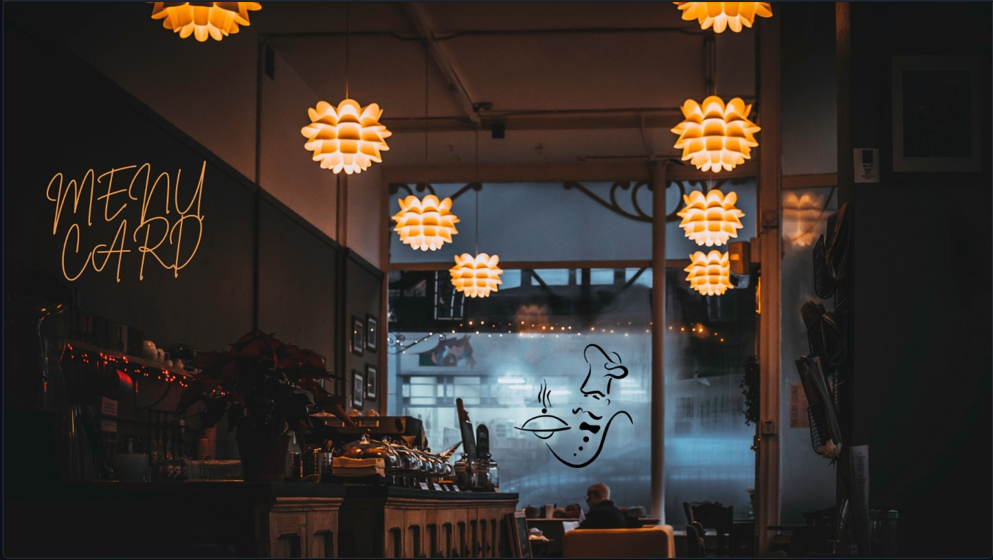

# THANK YOU!!!